### Garbage Collection

In Java destruction of object from memory is done automatically by the JVM. When there is no reference to an object, then that object is assumed to be no longer needed and the memory occupied by the object are released. This technique is called **Garbage Collection**. This is accomplished by the JVM.

Unlike C++ there is no explicit need to destroy object.

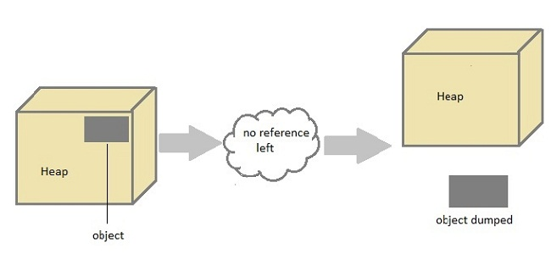

#### Can the Garbage Collection be forced explicitly ?

No, the Garbage Collection can not be forced explicitly. We may request JVM for **garbage collection** by calling **System.gc()** method. But This does not guarantee that JVM will perform the garbage collection.

#### Advantages of Garbage Collection

1. Programmer doesn't need to worry about dereferencing an object.
2. It is done automatically by JVM.
3. Increases memory efficiency and decreases the chances for memory leak.

#### finalize() method

Sometime an object will need to perform some specific task before it is destroyed such as closing an open connection or releasing any resources held. To handle such situation **finalize()** method is used. **finalize()** method is called by garbage collection thread before collecting object. Its the last chance for any object to perform cleanup utility.

Signature of **finalize()** method

protected void finalize()

{

//finalize-code

}

#### Some Important Points to Remember

1. finalize() method is defined in **java.lang.Object** class, therefore it is available to all the classes.
2. finalize() method is declare as **proctected** inside Object class.
3. finalize() method gets called only once by a Daemon thread named GC (Garbage Collector)thread.

#### gc() Method

**gc()** method is used to call garbage collector explicitly. However **gc()** method does not guarantee that JVM will perform the garbage collection. It only request the JVM for garbage collection. This method is present in **System** and **Runtime** class.

#### Example for gc() method

public class Test

{

public static void main(String[] args)

{

Test t = new Test();

t=null;

System.gc();

}

public void finalize()

{

System.out.println("Garbage Collected");

}

}

OutPut:--

Garbage Collected